**Machining Data**

This repository contains audio data that was collected from a Pocket NC V2-10, which is a tabletop 5-axis CNC Machine. The tool used is a Datron Single Flute End Mill, 3mm (0.11811 inch) diameter, 1/8" shank.

The main link that contains the data is [Machining Data](https://arizonastateu-my.sharepoint.com/:f:/g/personal/avarghe8_asurite_asu_edu/EvLGmOa0deJDoWdpl4ODjkwBHZV7OU36Y5YPn60UrQGP7Q?e=fhdmzR).

The one drive link contains audio which is from different machine processes like facing, etc.

The below table shows the Design of Experiment table that was done to collect the audio for the facing machining operation.

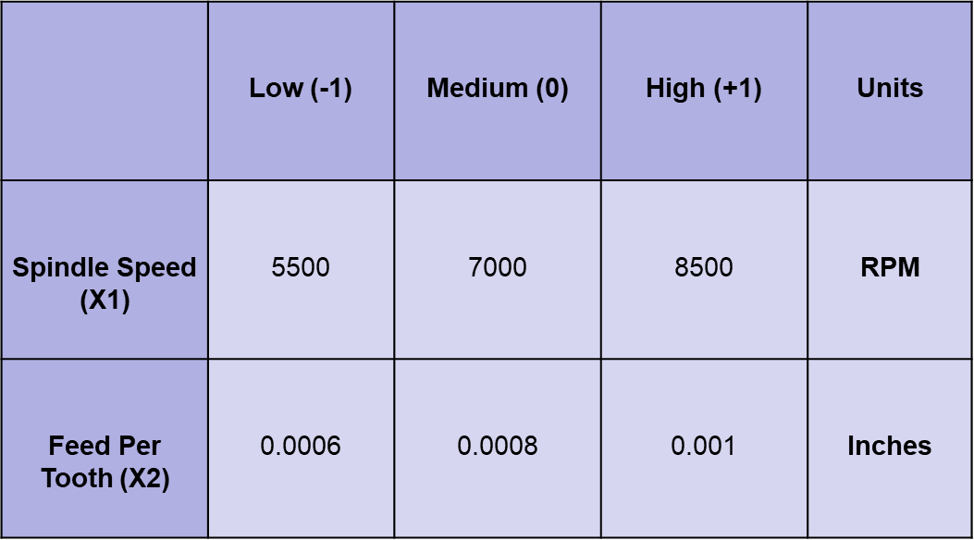

Sample 1 and 2 are 10 sec snippets of the machining audio.